**ACTIVITY-2**

**Satellite Communication:**

Satellite communication is a technology that utilizes artificial satellites to transmit and receive data, voice, and video signals between different locations on Earth. It enables global communication by relaying information through space, facilitating various applications such as television broadcasting, internet access, and telecommunications.

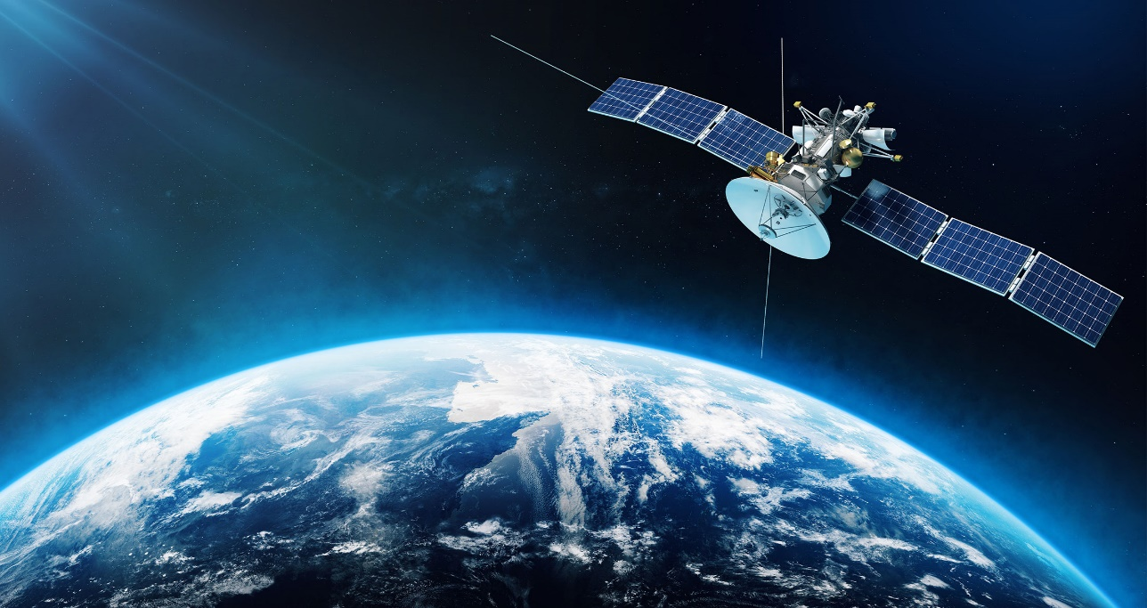

**Components of Satellite Communication**

1. **Satellites**:
   * **Types**:
     + **Geostationary Satellites (GEO)**: Positioned at about 35,786 km above the Earth, they orbit at the same rate as the Earth’s rotation, allowing them to maintain a fixed position relative to the surface.
     + **Low Earth Orbit Satellites (LEO)**: Orbit at altitudes between 180 km and 2,000 km. They are closer to Earth, resulting in lower latency but require a larger constellation for coverage.
     + **Medium Earth Orbit Satellites (MEO)**: Positioned between LEO and GEO, commonly used for navigation systems like GPS.
   * **Components**: Include transponders (which receive and transmit signals), antennas, and power systems.
2. **Ground Stations**:
   * Facilities equipped with antennas and other equipment to communicate with the satellite. They can transmit signals to the satellite and receive signals back
3. **User Equipment**:

* Devices like satellite phones, satellite modems, and dishes that allow end-users to send and receive signals.

**How It Works**

1. **Signal Transmission**: The ground station sends a signal to the satellite. The signal is modulated for effective transmission.
2. **Reception and Amplification**: The satellite receives the signal through its antennas, amplifies it, and then retransmits it back to Earth.
3. **Receiving Signal**: The ground station or user equipment receives the transmitted signal, which is demodulated to retrieve the original data.

**Applications**

* **Television Broadcasting**: Satellite TV services transmit signals directly to consumer satellite dishes.
* **Internet Services**: Satellite internet provides connectivity in remote areas where traditional infrastructure is lacking.
* **Telecommunications**: Enables long-distance phone calls and data transmission.
* **Global Positioning Systems (GPS)**: Satellites provide location and timing data for navigation.
* **Meteorology**: Weather satellites monitor atmospheric conditions and provide data for forecasting.

**Advantages**

* **Global Coverage**: Satellites can cover vast areas, including remote and underserved regions.
* **Quick Deployment**: Once in orbit, satellites can provide services without the need for extensive ground infrastructure.
* **Broadcasting**: One satellite can transmit signals to thousands of users simultaneously.

**Disadvantages**

* **Latency**: GEO satellites can experience higher latency due to the distance signals must travel.
* **Cost**: Launching and maintaining satellites can be expensive.
* **Weather Dependence**: Signals can be disrupted by adverse weather conditions like heavy rain (rain fade).

**Key Elements:**

* **Satellites**: Orbiting platforms that carry transponders to receive and transmit signals.
* **Ground Stations**: Facilities equipped with antennas that communicate with the satellites.
* **User Equipment**: Devices like satellite dishes and modems that connect end-users to the satellite network.